In Javascript, every value is either an Object or a primitive value.

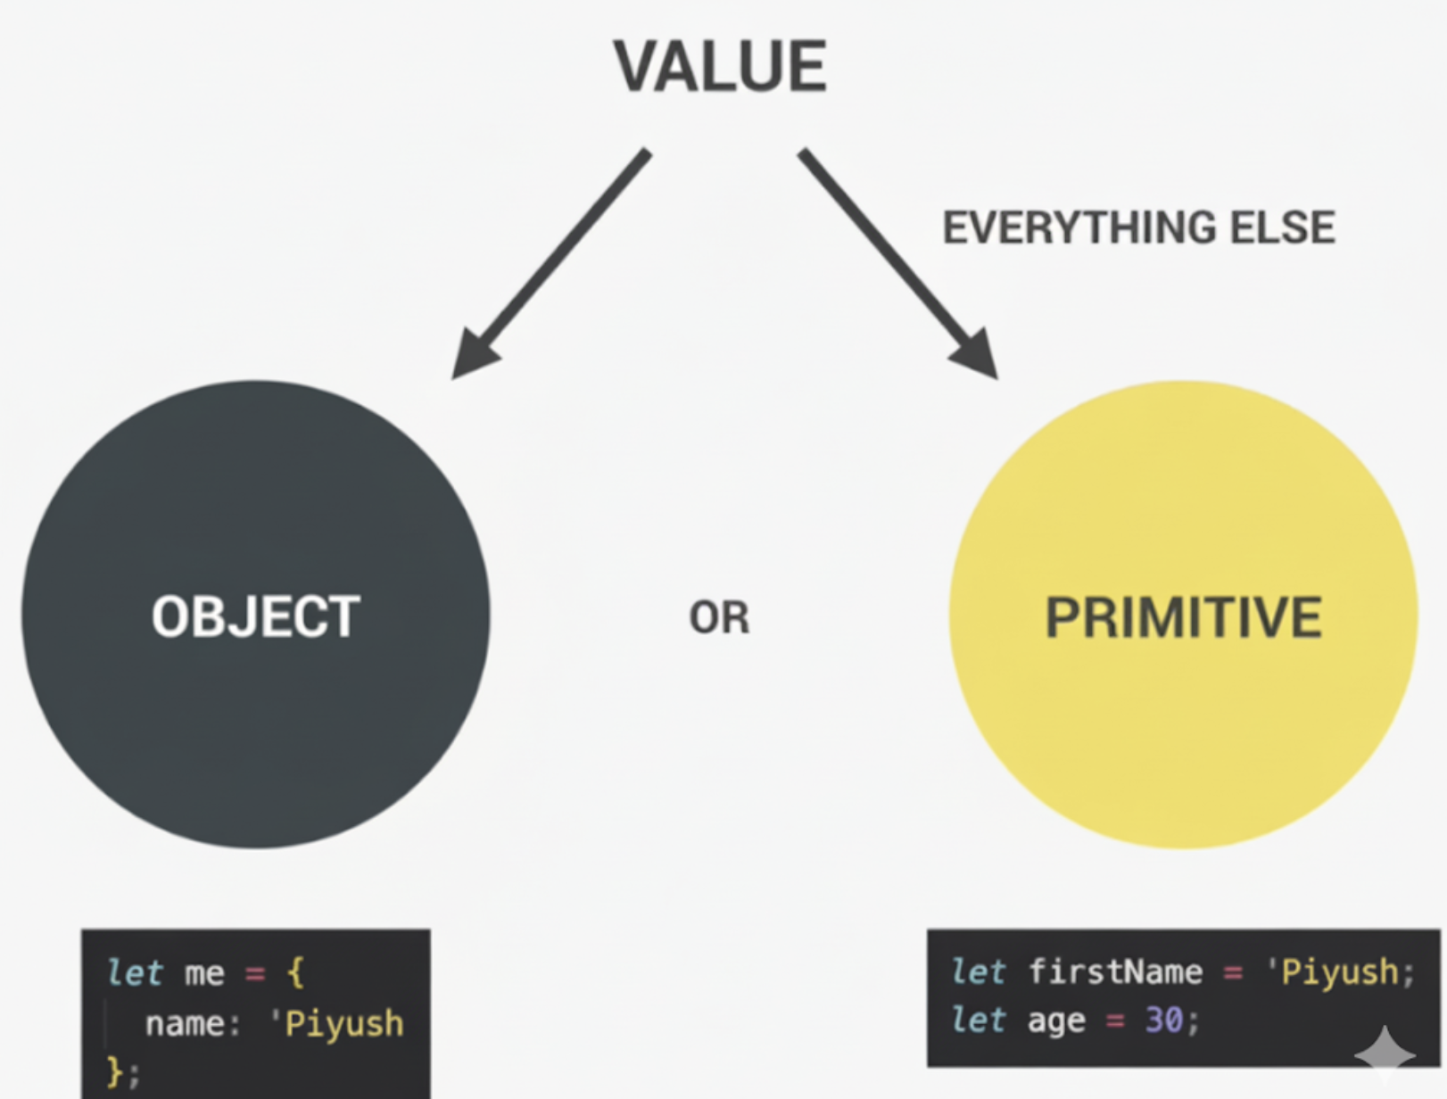

A value is only primitive when it is not an object.

Numbers are always floating point numbers which means they always have decimals even if we don't see them or define them. For example, let age = 23 is exactly like having 23.0.

All numbers are of type Number.

We use boolean values to make decisions.

These are the 3 most important data types.

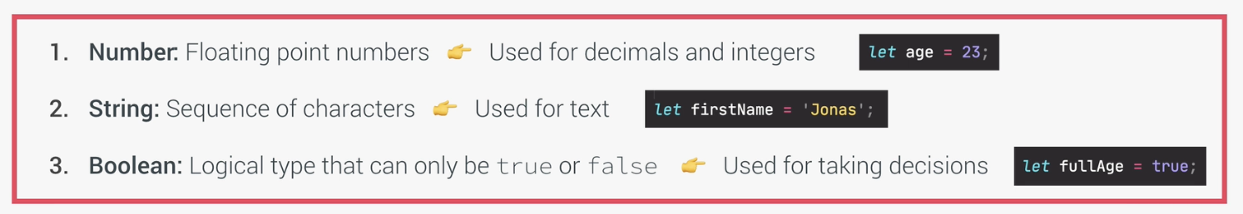
undefined means empty value.

null also means empty value.

We have a Symbol data type that was introduced in ES2015 but it is not really useful.

In ES2020, BigInt was introduced to store integers that are too large to be represented by the number type.

These are the 7 Primitive types in Javascript.

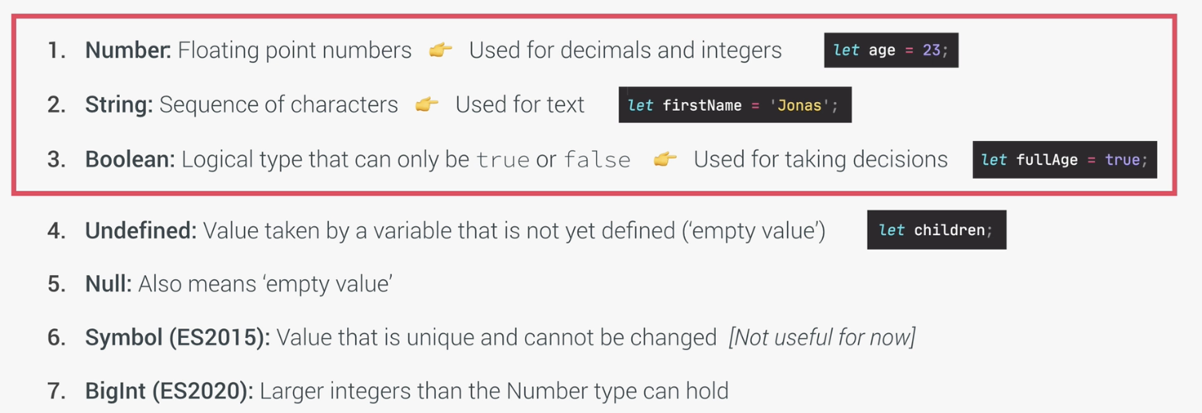

Javascript has a feature called dynamic typing. This means that when you create a new variable, you do not have to manually define the datatype of the value that it contains. JS automatically determines the datatype of the value when it is stored into a variable.

In JS, it is the value that has the type, not the variable. So, variables simply store values that have a type.
Now another important application of dynamic typing is that later in our code, we can assign a new value with a different data type to the same variable without a problem.
For example, variable x can initially be a number and later be a string.
In VSCode, we can automatically add comments by using command or Control + / shortcut.
We can use a multi-line comment by /* and */ and put anything in between that we want to comment.
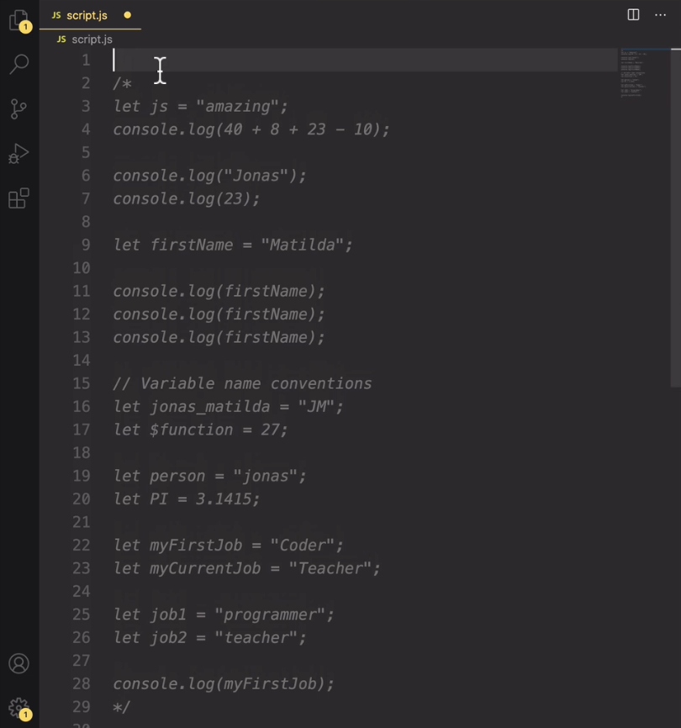
So, we can hide this code from executing without deleting it.
A boolean can only be true or false.
typeof is a special operator.
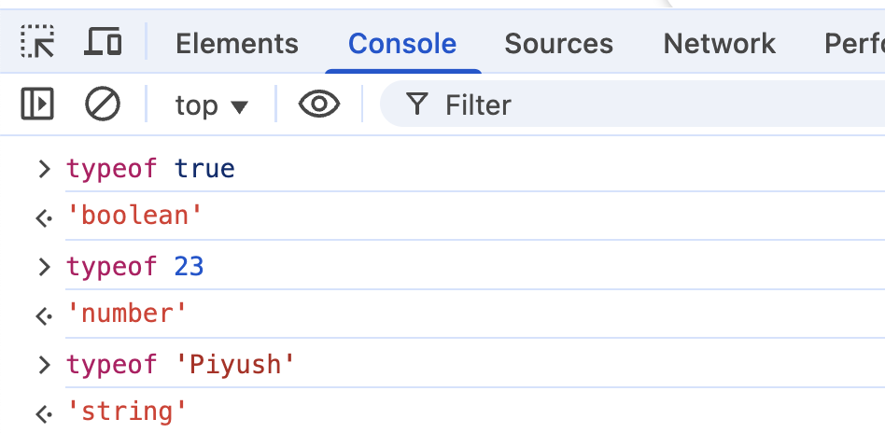
We always use single or double quotes to create a string.
Dynamic typing simply means that we can easily change the type of a value that is held by a variable.
If the variable is already defined earlier, when we change its value, we do not use let/const again. Just the variable = new Value.
Its like putting a book in a box. And then later taking the book out of the box and instead putting a phone in the box.
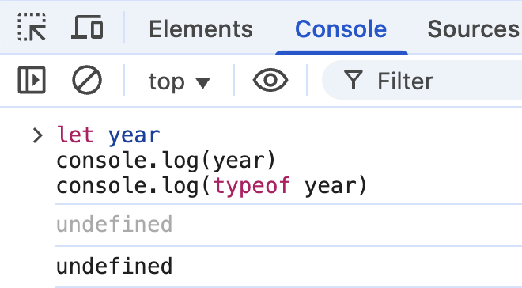
undefined is both the value and type of the value.
This is a bug in Javascript which doesn't make any sense at all. null is not an object and the output should be null.
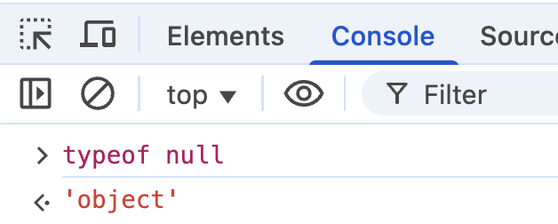
let, const and var
There are 3 different ways of defining a variable.
let and const were introduced in ES6. So they are part of modern JS. While var keyword is the old way of declaring variables.
We use let for the variables that can change. This is also called reassigning a value to a variable or mutating a variable. Example:
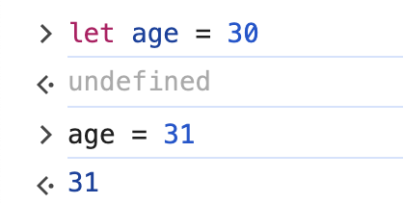
A let variable can be declared empty as we can change it later.
We use the const keyword to declare variables that are not supposed to change at any point in the future.
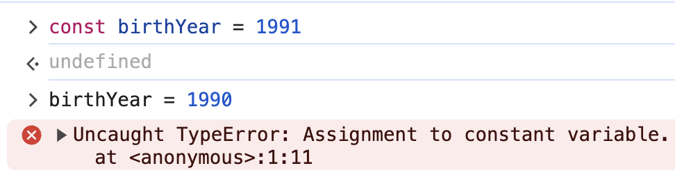
A constant is an immutable variable. Birth year is the perfect example of this.
We can not declare empty const variables.
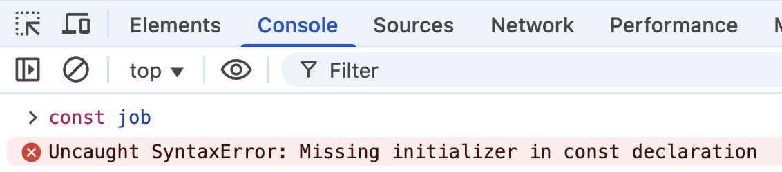
With const, we need an initial value.
As per best practice, always use const and only use let when the variable value needs to change.
As per best practice, we should have as little variable mutations as possible because changing variables introduces a potential to create bugs.
Don't use the var way of creating variables. This code works fine. In this example, var works just like let.
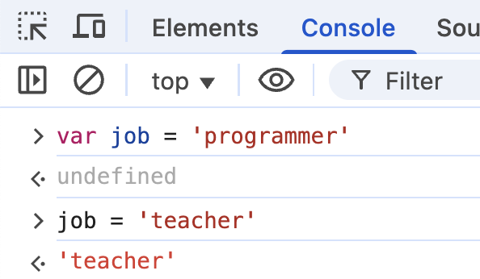
We don't even have to declare variables at all and we can use this code. But this is a bad way of writing the code as it does not create the variable in the current scope. Instead, Javascript will create a property on the global object.
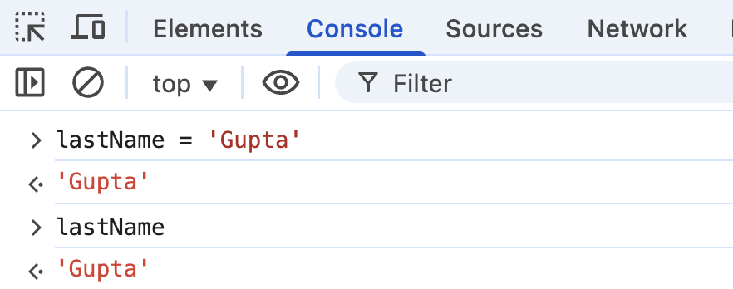
This is how we can use emojis in our code.
On MAC, press Command + Control + Space.
On Windows, press Windows key + dot(.).
